- Missing UOM’s on BOM

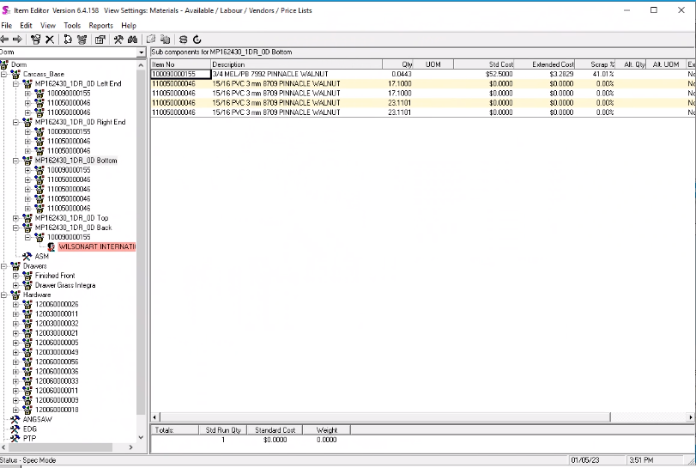
Answer:
The UOM value is coming from the ItemSpecStruc. UOMID field which is NOT currently populated in all scenarios.
Already verified that this is in the App Integration common code that validates the BOM data before sending it to the spec builder.
Basically, this needs a small code modification.

2 User Defined
- Add user-defined minimum L X W T
- Add L x W onto bom description
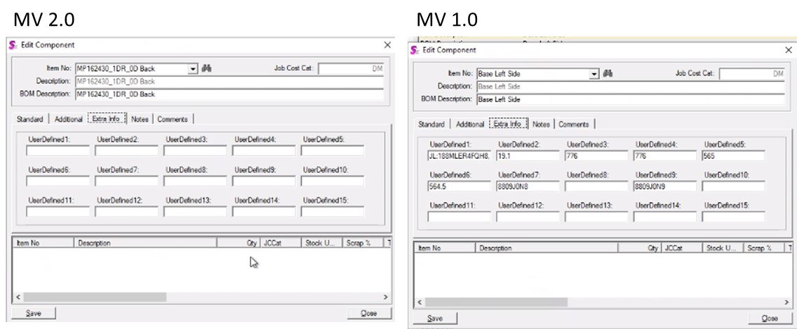
Answer:
The dimensions are already in the regular import queries. The same will be done for the optimization import queries, which are the one use for these products.
3 Round to 6 decimals

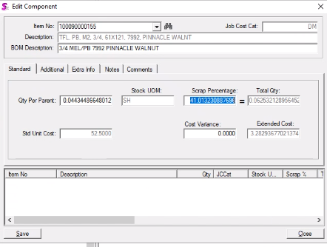
Answer:
These values were intentionally NOT rounded to avoid quantity discrepancies when calculating the quantity to complete during partial work order completions. In the past we had problems of this nature, so we decided NOT to round the quantity per parent to avoid rounding issues.
4) Edgeband
Add dimension to ED bom description

Item Master UOM is linear ft
So Qty is in linear ft.

If require 16 in Q = 1.333 lin ft
Total edgeband list is
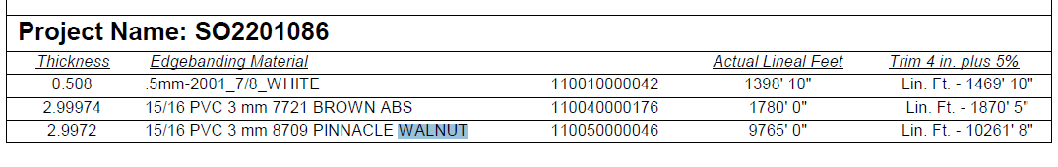
Answer:
The adding dimensions will be done via point 2 when matching the optimization queries with the regular ones.
Regarding the actual quantity per parent, as shown in the below picture our import query is currently getting the quantity value for the edgebanding from the MVEdgebanding.linFt field, which is a Microvellum field that based on the name is supposed to have the quantity expressed already in linear feet, but in this case that does NOT seem to be the case, it seems that it is storing the value in inches.
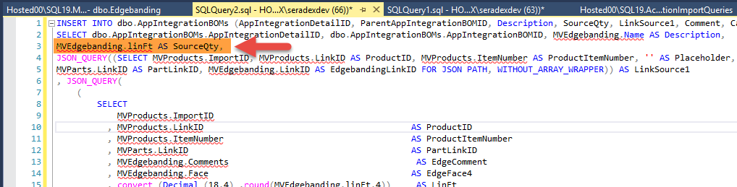

For the example we were analyzing, the “MP182430_1DR_0D Bottom” component has the shown below dimensions:
Width = 585.001 mm (this expressed in inches is 585.001/25.4 ~= 23.11 inches that corresponds to the quantity per parent in the MVEdgebanding.linFt field).
Length = 432.354 mm (this expressed in inches is 432.354/25.4 ~= 17.1 inches that corresponds to the quantity per parent in the MVEdgebanding.linFt field).
585mm
432 mm

432

Here the dimensions of the “MP182430_1DR_0D Bottom” are shown:
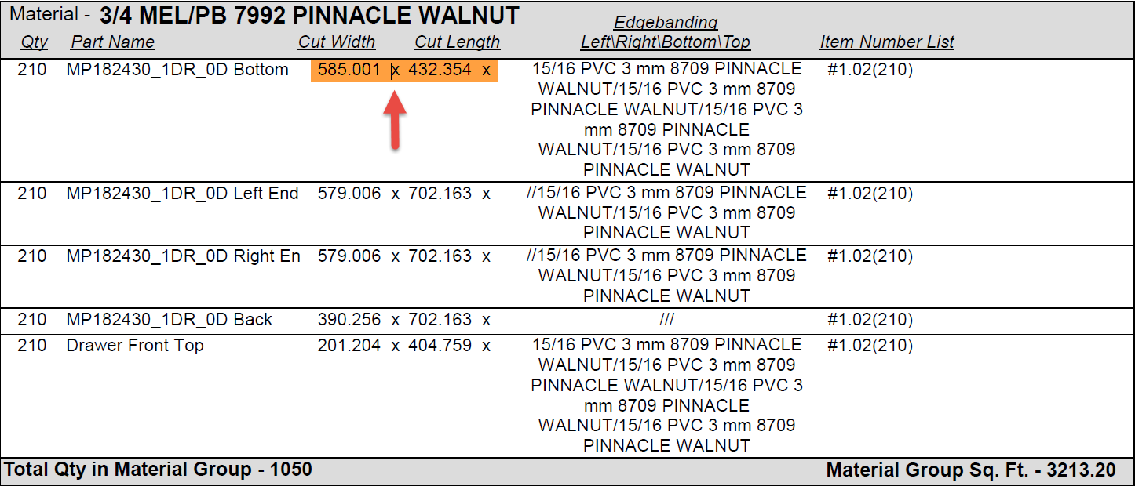
Since in OrderStream that quantity is expected in Linear Feet (stock uom), as a solution we could convert that value directly in the import query or apply a factor based on the category of the item. The only problem with this is the fact that there is no guarantee that the value in the MVEdgebanding.linFt field will be always expressed in inches since the name implies that it should be expressed in Linear Feet.

